- Type the following code in a text editor to create a short JavaScript function in your HTML page that displays the inner width and height and outer width and height of a window: 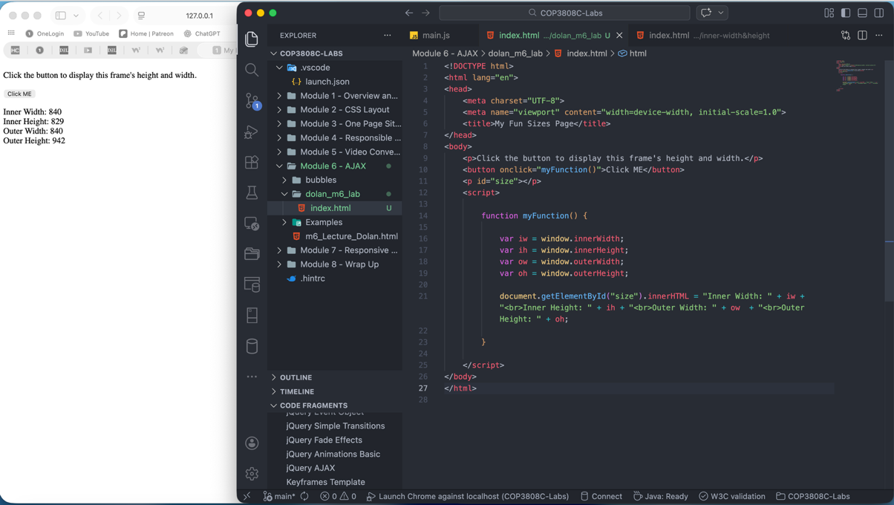
- Type the following code in a text editor to create a short JavaScript function in your HTML page that changes the color of the text in a paragraph to red when the user scrolls: 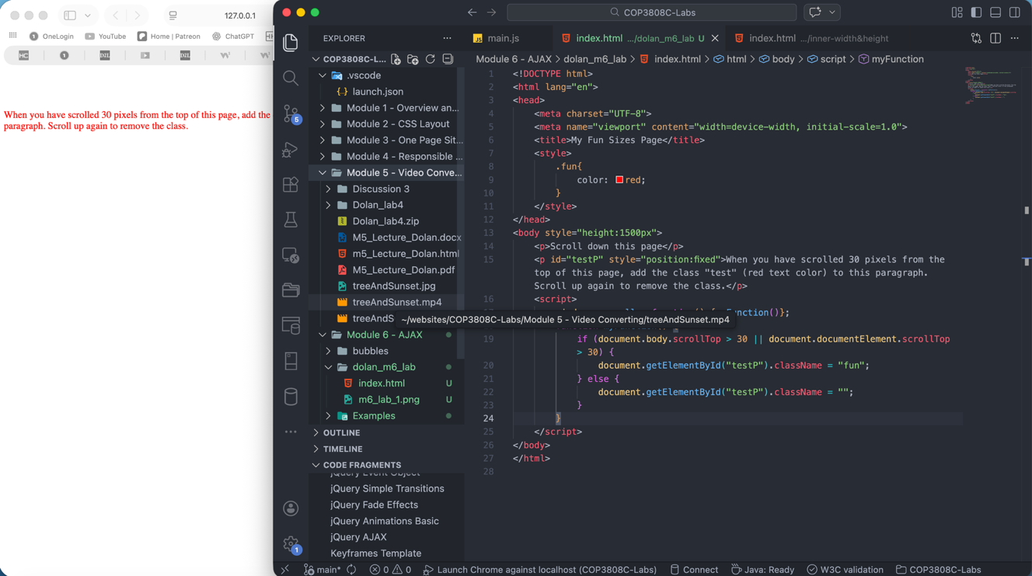
- Repeat-x centered: 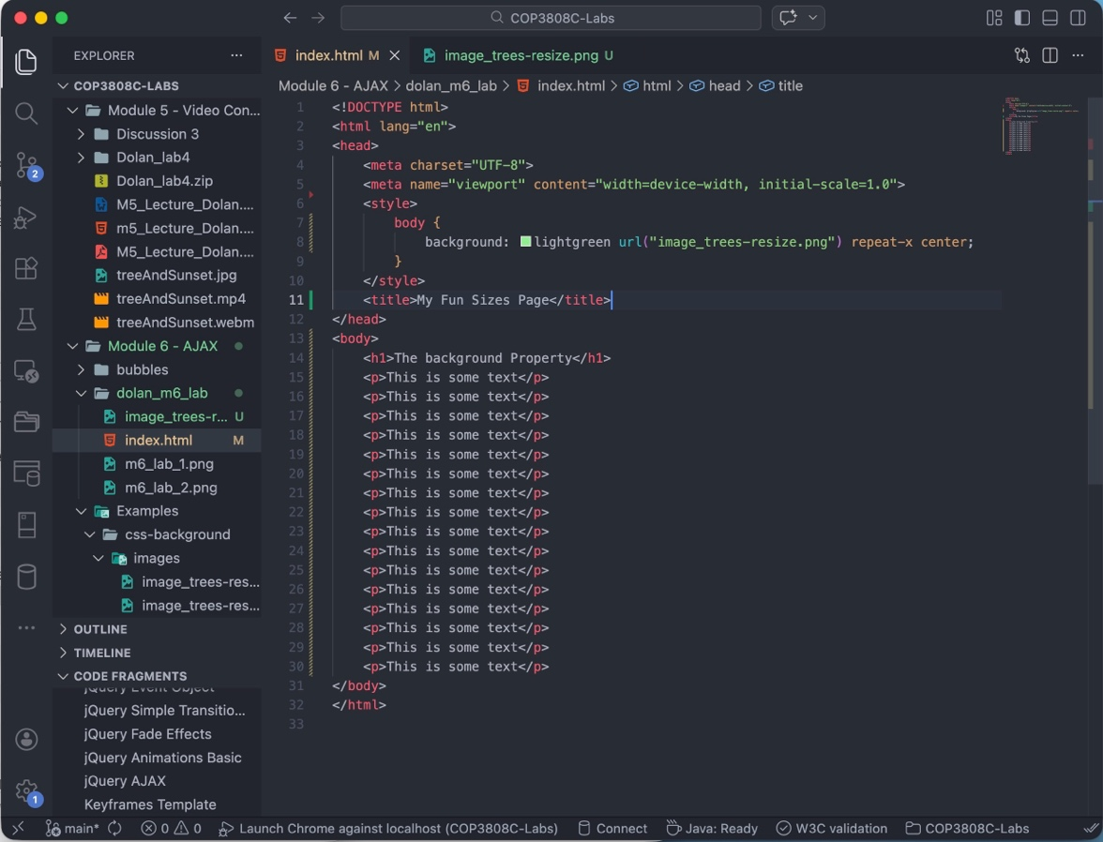
- Repeat-y left: 